Energy Solutions
RR 5 Shawville Québec J0X 2Y0
Voice 819.647.5092
Fax 819.647.6082
mheat@mha-net.org
www.heatkit.com

Revised February 16, 2004

Chimney Connection
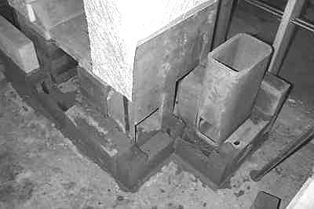
Figure 1. Typical Chimney Connection

This shows a chimney that shares a common wall with the heater facing. Normally, the chimney would be 4” further out, and there would be 8” - 9” of masonry between the 8x12 flue liner and the heater core.

A short length of horizontal flue liner connects the heater core with the chimney.

A front chimney cleanout is shown. This chimney is slab on grade, with no cleanout in the basement. Also note the cleanout cut into the bottom heater channel.

There is very little temperature stress and movement at the bottom of the heater. Therefore, the chimney connection is simply slushed in solid with ordinary brick mortar.
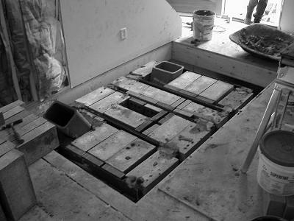
Figure 2. Chimneys coming up through foundation.
This illustration shows a heater pad with a basement foundation underneath. The heater will connect with the flue liner on the right, which goes to a clean out in the basement. The flue liner on the left is for a separate fireplace in the basement.

On this foundation, there is no cantilevered reinforced concrete slab. Instead, the cantilever is done with angle irons, and filled in with 4” solid blocks.

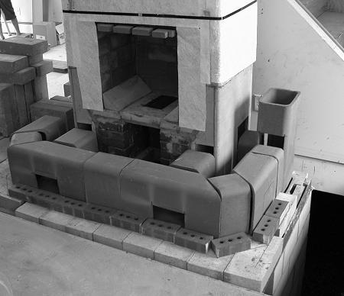
Figure 3. Dry Heated Bench layout and chimney connection
This is the same heater as Figure 2 above. It shows a dry layout for a heated bench and the chimney connection. The flue liners for the bench will sit on an additional 4” of brick.

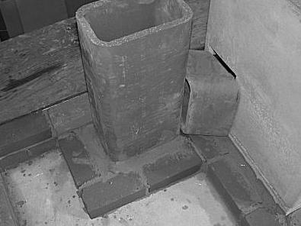
Figure 4. Chimney Connection.
This chimney also shares a common wall with the heater.

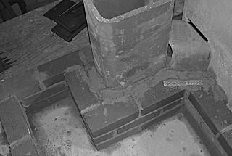
Figure 5. Mortar slush around flue liners.
Note the galvanized brick tie at the stacked corner joint. A brick tie is used every course.

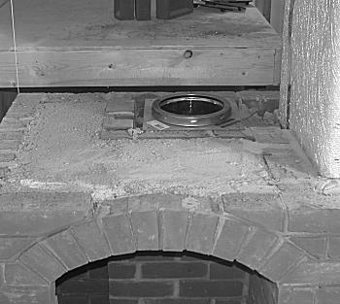
Figure 6. Metal chimney connection
This is the same chimney as in Figure 5.
A U.L. listed component called an “anchor plate” is used to make the transition to metal chimney. Not shown is a sliding damper, installed in the brick portion of the chimney below the anchor plate. The handle for the sliding damper is inside the wood box.

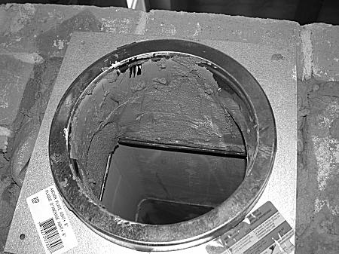
Figure 7. Anchor Plate Detail
This anchor plate if for “Excel” brand chimney from ICC (www.icc-rsf.com). It is a high quality chimney that only uses 1” of insulation, giving a 10” o.d. for an 8” i.d. chimney. It is also very lightweight, making it easy to install.

Ordinary mortar is used to parge a transition from the 8x12 flue liner (6.5” x 10.5” actual). Because flue temperatures are low at this point, the 600F service limit of the portland cement will not be exceeded. Note the steel sliding damper frame just below the parging.

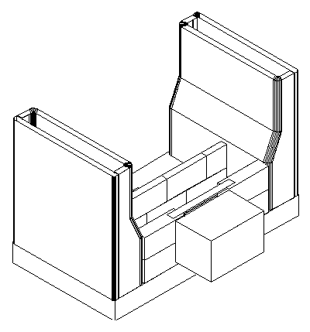
Figure 8. Rear Chimney Connection Detail.
The rectangular block represents a short length of 8x12 flue liner.
A metal bar (supplied with the core hardware) is used to span the firebrick opening.

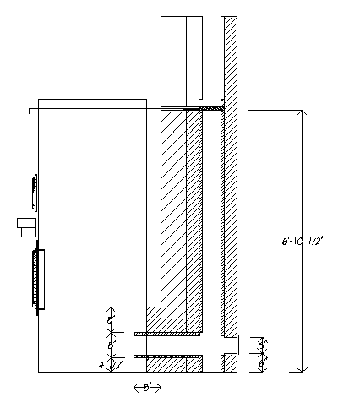
Figure 9. Rear Chimney Connection.
In this example, the chimney is on the other side of a wall.

The handle of the sliding damper is extended so that it can be operated from the front of the heater.

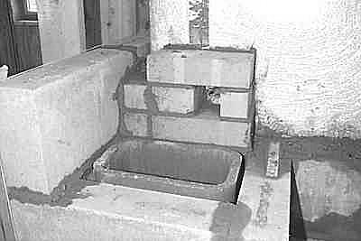
Figure 10. Bypass Detail.
This is a short circuit into the chimney (see core assembly instructions for details).
It allows for easier cold starts when the heater is not in daily use.

