Voice 819.647.5092
Fax 819.647.6082
mheat@mha-net.org
www.heatkit.com

RR 5 Shawville Québec J0X 2Y0

Revised November 24/03

Modified Combustion Air System
prepared for:

William H. Reynolds
Solutions for Better Breathing
P.O. Box 83008
Fairbanks, Alaska 99708
ph. 907-479-0518
william@alaska.net

Figure 1. Standard Air System
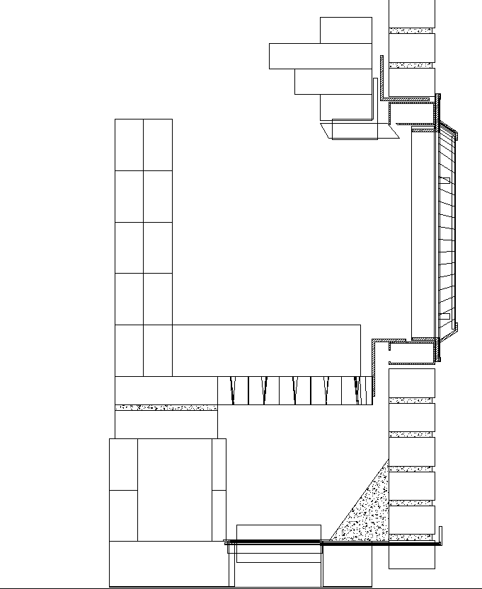
Figure 2. Modified Air System - Section

Description:
An “air frame” is fabricated from 2”x4”x1/8” hollow steel tubing. There is a 1” air inlet slot cut into the bottom, and a 1/2” air outlet slot in the top. Refer to Figure 2, section view.
A 3”x5”x1/4” angle iron is used to create the air supply to the frame
The inside dimensions of the air frame are 18” w. X 19” h.
Underfire air enters through the floor to help burn the coals during the charcoal phase of the burn.
Instead of a cast iron grate, tapered cylindrical castable refractory inserts are used, supported on a steel frame (not shown in the drawings, refer to Figure 6
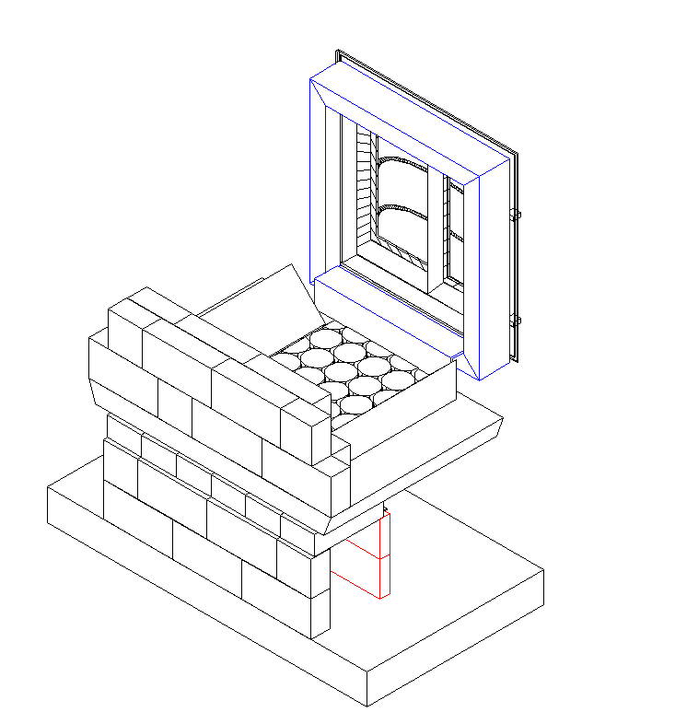
Figure 3 Isometric View.
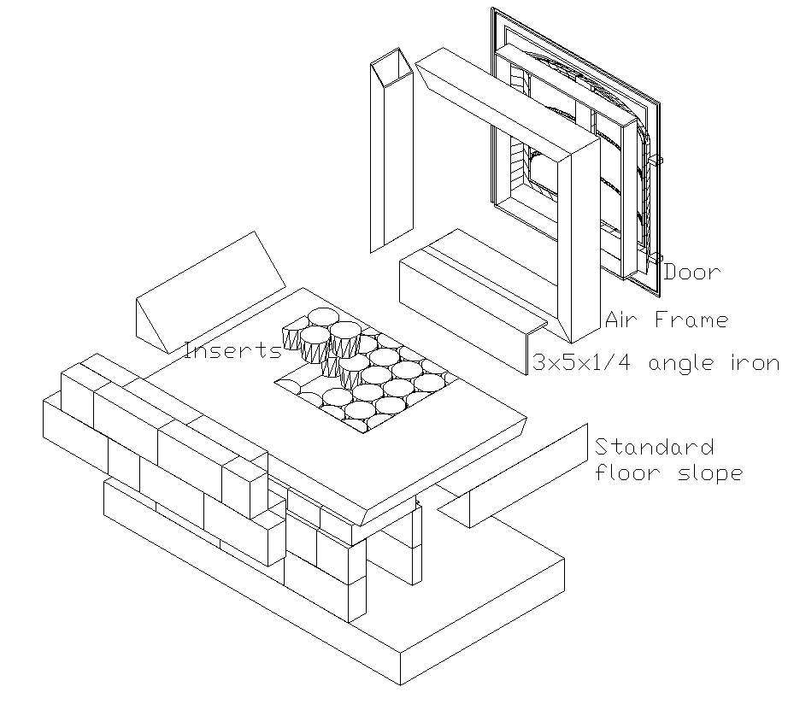
Figure 4. Exploded View.

Figure 5
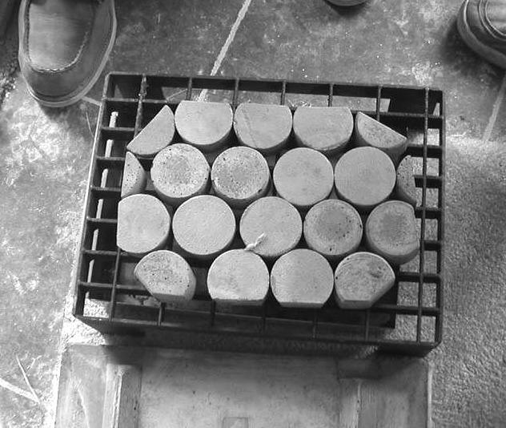
Figure 6 Example of a support frame for castable refractory floor inserts. (www.tigchelkachels.nl)
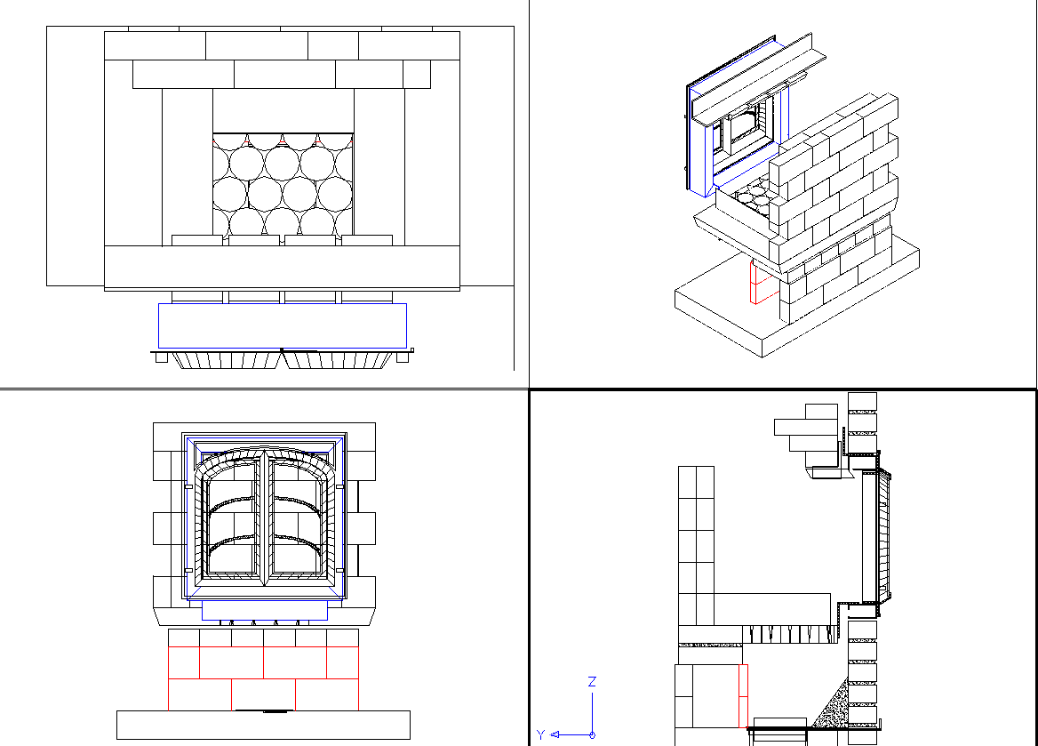
Figure 7

Insulating Base Slab, Ceiling Slab

These are the same as our standard slabs, except that the overall width is increased by 2” to accomodate 2-1/4” thick firebricks for the side channels, instead of the thinner precast side channels.

This shows the side channel layout with 2-1/4” thick firebricks on edge. Note the expansion joints where the channels meet the firebox. This is best done with a strip of ceramic fiber ripped down to about 1/2” thickness. Build the inside first, then add the ceramic fiber expansion strips, then build the downdraft channels.

This shows the dimensions for the standard (unmodified) insulating base slab with a cutout for the air control and ash drop to the basement.

The slab is cast from a lightweight concrete formulation.

Size of modifed slab is 43.5 X 23

This shows the standard ceiling slab. It is cast in 3 sections for convenience in installation. It is 3 -4” thick, depending on the strength of the castable used. It has the same dimensions as the base slab.

Pivoting Air Shutoff

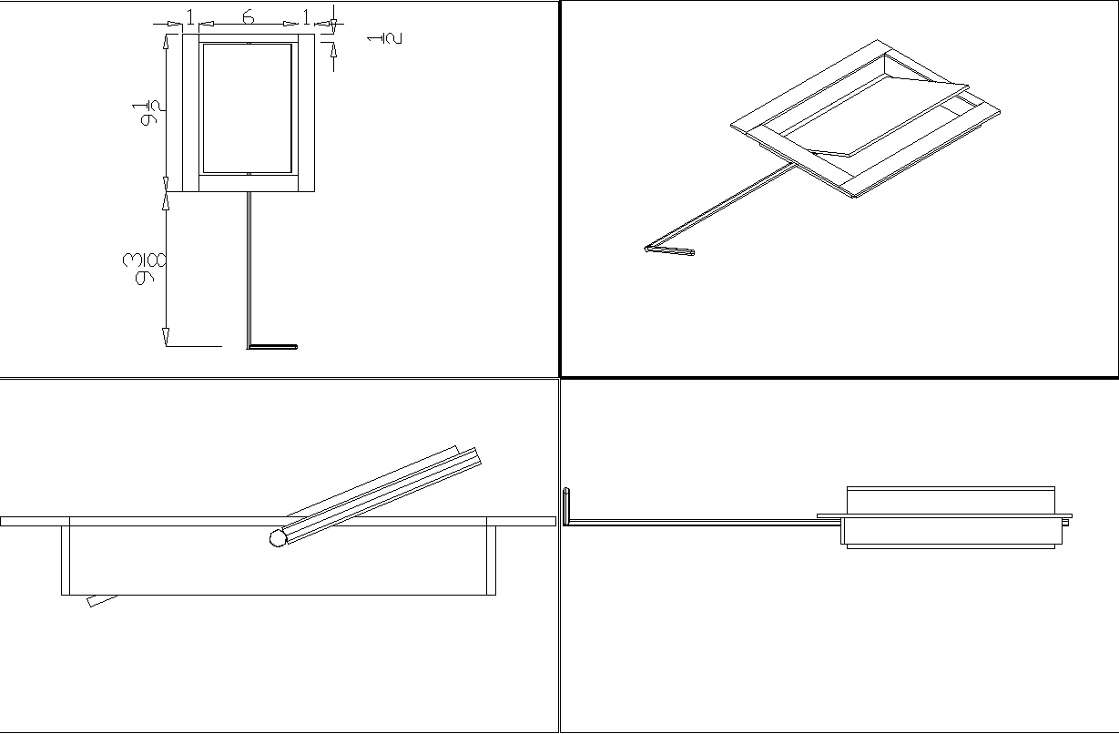

Note: Air shut off is only required if combustion air is coming from outside, and the heater sits on a foundation with an ash pit. Air inlet from outside is into the ashpit.

Ceiling Transitions

These are cast from a lightweight castable.
This can also be built from firebrick (headers with angled ends)

Modified core with firebrick side channels - Isometric view

