Voice 819.647.5092
Fax 819.647.6082
mheat@mha-net.org
www.heatkit.com

Energy Solutions
RR 5 Shawville Québec J0X 2Y0

Drawings for Held Heater
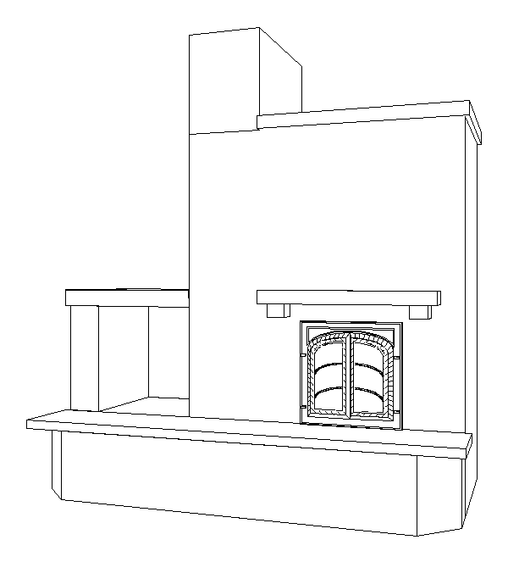
Figure 1. Perspective (Bench not as built)
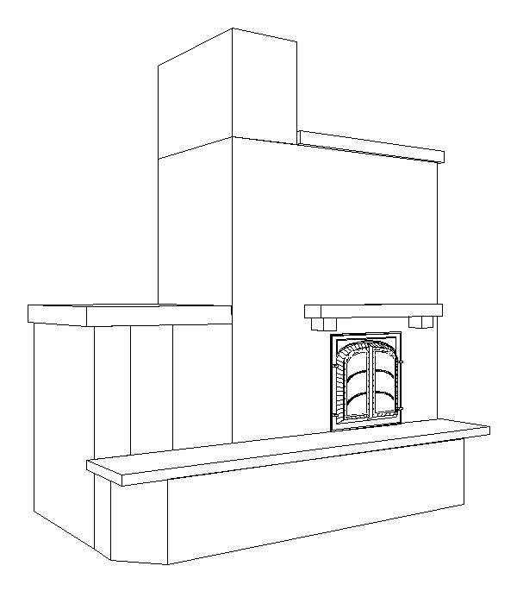
Figure 2. Perspective (Bench not as built)
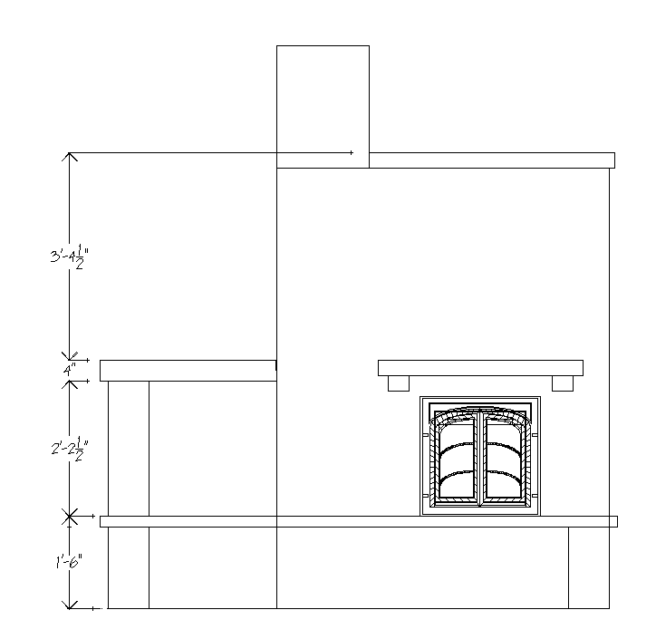
Figure 3. Front Elevation
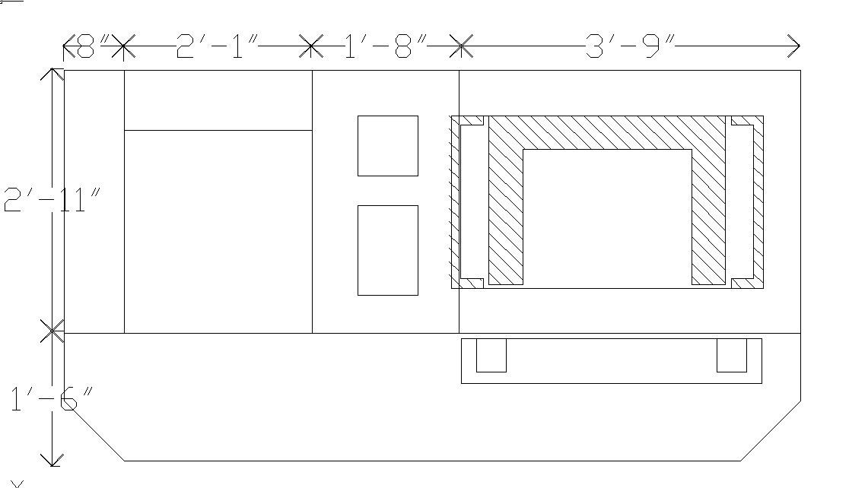
Figure 4. Plan
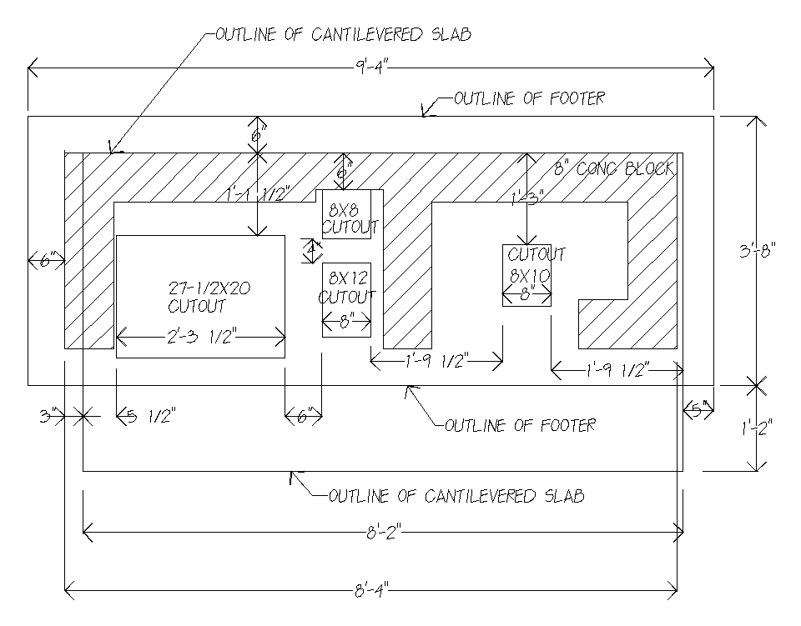
Figure 5. Foundation
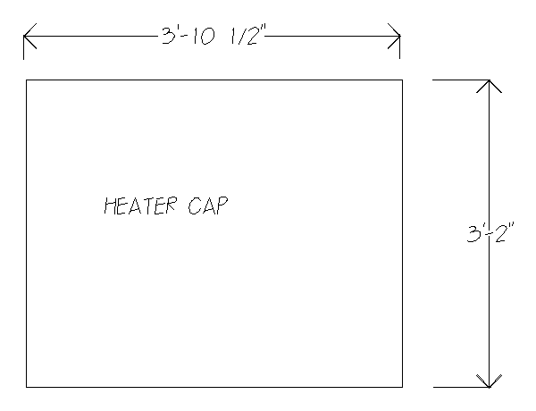
Figure 6. 3” Marble Slab to Cap Heater

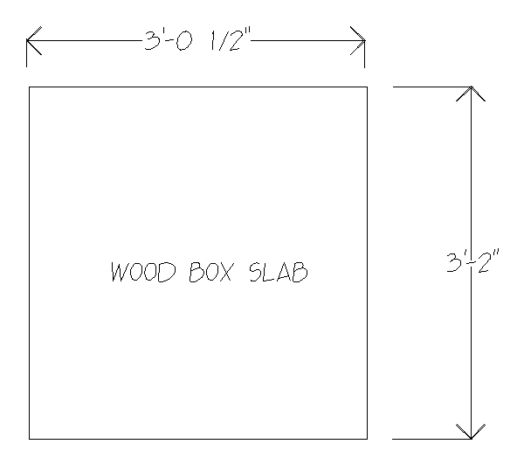
Figure 7. 3” Marble Slabe to Cap Woodbox
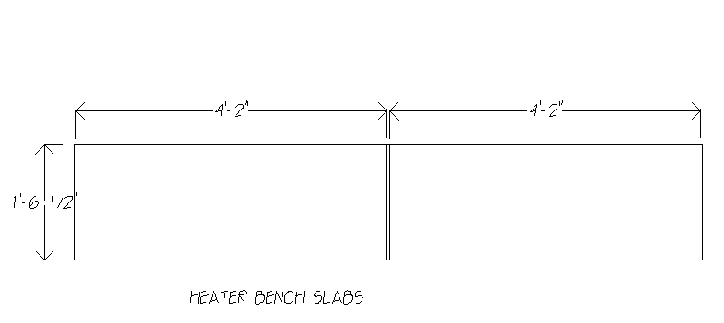
Figure 8. 3” Marble Slabs to Cap Heated Bench
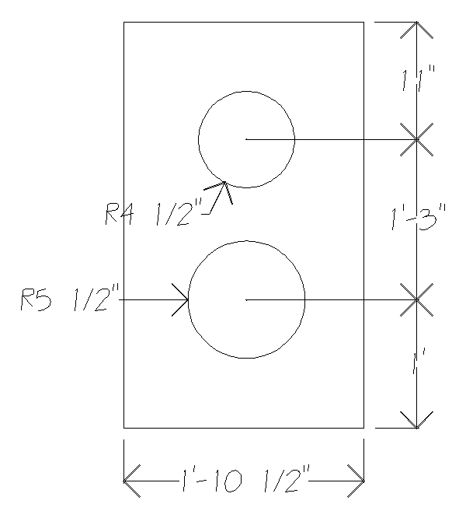
Figure 9. Marble Slab to Cap Chimney
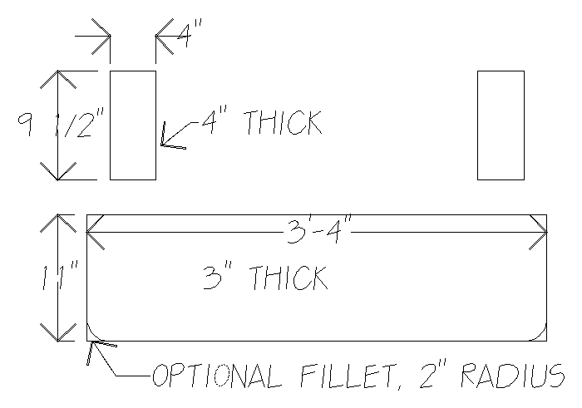
Figure 10. 3” Marble Slabs for Mantle
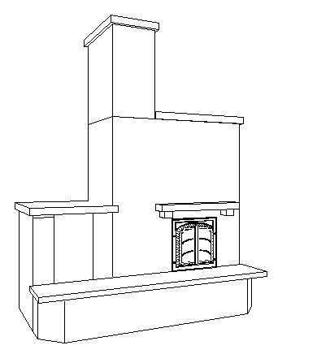
Figure 11 . Perspective Showing Slabs (Heated bench not as built)

