Voice 819.647.5092
Fax 819.647.6082
mheat@mha-net.org
www.heatkit.com

48” X 54” Rumford

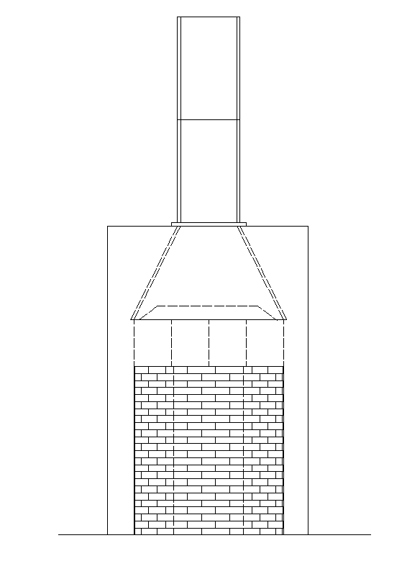

Energy Solutions
RR 5 Shawville Québec J0X 2Y0

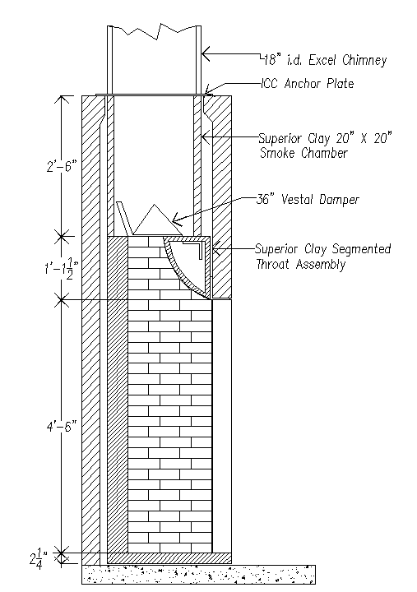

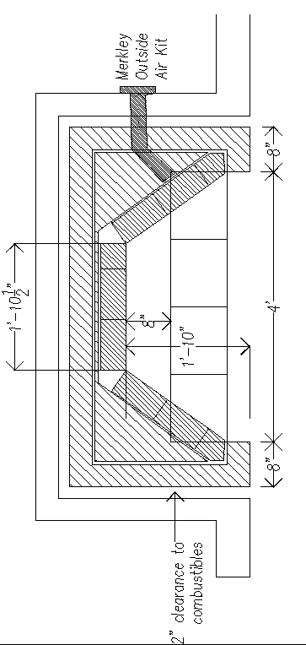

Segmented Throat Detail

